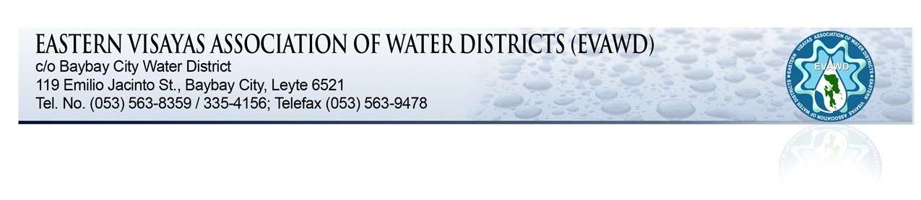
TO : GENERAL MANAGERS, BOARD OF DIRECTORS,
HRMO'S, DIVISION MANAGERS AND CONCERNED PERSONNEL

SUBJECT : EVAWD 4th QUARTERLY MEETING

DATE : DECEMBER 10-11, 2015
X ==============================================/

The Eastern Visayas Association of Water Districts (EVAWD) will hold its 4th quarterly meeting on December 11, 2015 (Friday) at Maasin Country Lodge, Maasin City, Southern Leyte.

The following are the activities:

- December 10 - Arrival & Registration of Participants.

- PM: Dinner - Fellowship

- December 11 - 8:00 A.M, EVAWD Meeting

Agenda: a) President's Time

b) Election of Officers for 2016-2017

c) Other Matters.

- Lunch.

-END-

A Registration Fee of ONE THOUSAND (P1,000.00) PESOS per participant to defray the expenses for the foregoing meeting on the 11th of December 2015.

It is very important that your confirmation as to the number of participants attending shall be made not later than December 7, 2015.

For further details and confirmation of attendance, you may contact Ms. Neneng Trigosa or Ms. Riza Quilla at telephone nos. 09175358130 or 09359555047. For room reservations, you can directly call Maasin Country Lodge at Telephone nos. (053) 570-8858 or (053) 381-2102.

Please be reminded of your unpaid quarterly dues to help defray the expenses needed.

Thank you for your continued support to our association.

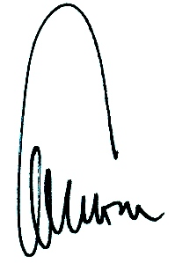

CYRIL LUIS L. ARRADAZA

