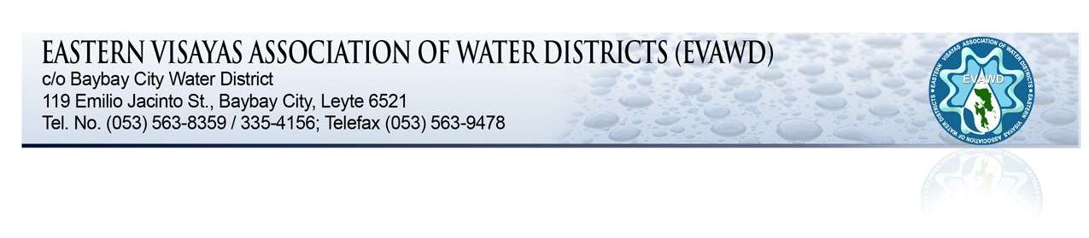

TO : ALL GENERAL MANAGERS
ALL BOARD OF DIRECTORS

FROM : CYRIL LUIS L ARRADAZA
EVAWD President
General Manager / BCWD

SUBJECT : 4th QUARTERLY MEETING

DATE : DECEMBER 16, 2013

X ==============================================/

The Eastern Visayas Association of Water Districts (EVAWD) will hold its 4th Quarterly meeting on December 19-20, 2013, Thursday to Friday at the Social Hall of Metropolitan Cebu Water District (MCWD), Cebu City.

A Registration Fee of EIGHT HUNDRED (P800.00) PESOS per participant to defray the expenses for food, venue and other miscellaneous expenses during the meeting. Thus, it is very important that your confirmation as to the number of delegates attending shall be made not later than December 18, 2013.

For further details and confirmation of attendance, you may contact Ms. Elsie C. Almario at Telephone Nos. (053) 563-8359; 335-4156; 563-9478, or Cel. No. 09064571725 (globe) or 0932-4112360 (sun).

We shall be discussing the following:

- Damaged assessment caused by typhoon Yolanda for possible financial assistance.
- Performance Based Bonus.
- Other matters.

Thank you for your continued support to our association.
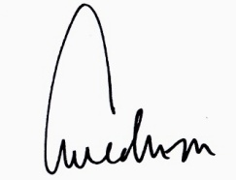

CYRIL LUIS L. ARRADAZA

PROGRAM OF ACTIVITIES
4TH QUARTER MEETING

SOCIAL HALL
METROPOLITAN CEBU WATER DISTRICT

December 19, 2013 (Thursday)

8:00AM - 5:00PM - Arrival, Registration and Accommodation of Participants

December 20, 2013 (Friday)

9:00 - 9:15 Invocation & National Anthem

9:15 - 12:00 Meeting Proper

- Damaged assessment caused by typhoon Yolanda
for possible financial assistance.

- Performance Based Bonus.

- Other matters.

12:00 NOON L U N C H

1:30 - 4:30 Continuation of Activities and OPEN FORUM

4:30 - 5:00 Closing Remarks

